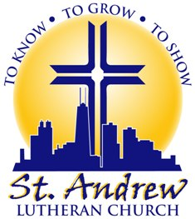
ST. ANDREW CHURCH NEWSLETTER TEMPLATE
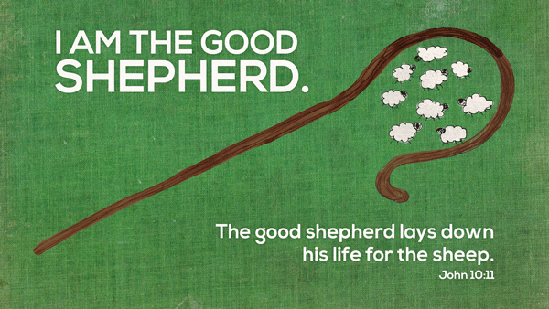
SEPTEMBER 2015

¹⁶ This is how we know what love is: Jesus Christ laid down his life for us. And we ought to lay down our lives for our brothers. ¹⁷ If anyone has material possessions and sees his brother in need but has no pity on him, how can the love of God be in him? ¹⁸ Dear children, let us not love with words or tongue but with actions and in truth.
1 John 3:16-18

⁹ “As the Father has loved me, so have I loved you. Now remain in my love. ¹⁰ If you obey my commands, you will remain in my love, just as I have obeyed my Father’s commands and remain in his love. ¹¹ I have told you this so that my joy may be in you and that your joy may be complete. ¹² My command is this: Love each other as I have loved you. ¹³ Greater love has no one than this, that he lay down his life for his friends. ¹⁴ You are my friends if you do what I command. ¹⁵ I no longer call you servants, because a servant does not know his master’s business. Instead, I have called you friends, for everything that I learned from my Father I have made known to you.
John 15:9-15
One of the most beautiful pictures in the Bible is that of Jesus as the Good Shepherd. The words in the picture above give so much comfort to all of us. Jesus is our Good Shepherd. The Good Shepherd lays down his life for the sheep. If you look at the passage in the right hand column you will see other sections of the inspired Apostle John’s writings where he talks about Jesus laying down his life for us. This is how we know what love is: Jesus Christ laid down his life for us. Greater love has no one than this, that he lay down his life for his friends. Then Jesus gives us that assurance; You are my friends. When we look to the cross, how can we ever doubt that Jesus loves us. Every time we sin, we look to the cross and know Jesus loves us and has forgiven us. Every time things are not going well in our lives and we wonder what God’s plan may be or why he is allowing things to happen we look to the cross and know that Jesus loves us. What an amazing thing that is. Nothing can separate us from the love of God that is in Christ Jesus my Lord. Jesus loves me this I know, for the Bible tells me so.

SUNDAY SCHOOL STARTS SEPTEMBER 13
St. Andrew Sunday School for children three years old through 8th
grade will begin Sunday September 13 from 10:45 – 11:30. Since the
closing of the school it is so much more important for your children to
attend Sunday School and learn more about Jesus. Please join us and
bring you friends as well.
St. Andrew Lutheran Church, 3658 S. Honore Chicago, IL 60609
St. Andrew Ministry Center, 3650 S. Honore, Chicago, IL 60609
773-376-5370 Visit us on the web: standrewchicago.org

Our Pastor:

Doug Semenske,
773-376-5370
Cell: 708-899-9059
Email: pastor@
standrewchicago.org

Our Secretary:

Margie Hendricks, 773-376-5370
Email:
churchsecretary@
standrewchicago.org

Our Worship:
Sunday at 9:30am

Our Bible Study:
Sunday at 10:45am
Friday at 10:00 am

Our Sunday School:
Sunday at 10:30 am

Sermons on the Web

Listen to Sunday sermons on our web page. Go to standrewchicago.org
Click on Church at the top then click on sermons to see a list of available sermons.
Sermons are also available on our Facebook page and iTunes

ATTENTION ST. ANDREW ALUMNI

I would like to follow up as to the responses received from our notification about the Alumni Association. We sent out 450 letters in August. We have received about 20 responses. We have added eight names to our email list and another seven who would like the Newsletters mailed to them. The responses whether to continue the Alumni Association are about even. We have also had many letters returned due to incorrect addresses or undeliverable. We resent letters to those that had forwarding addresses listed and are attempting to get correct addresses for the rest. As you can see, the number of responses is quite small considering the number of letters sent out. Those of you who came to our past reunions know that the number of people attending was also steadily declining. The last time we collected membership dues was in 2013. We had 78 dues paying members at that time. No final decisions have been made other than to add Alumni to our newsletter mailing list and mail the newsletters to those who requested them. If you have any other comments please email or call our pastor or secretary. Contact information is in the column to the right.

ST. ANDREW CHURCH NEWS

It was mentioned last month that it is is our goal to have one social/outreach activity each month. Unfortunately our Outdoor Service had to move inside due to rain. We were all set up in front of the church. The rain came 15 minutes before the start of the service. The continental breakfast went very well even though it was held in the church basement instead of outside in the Ministry Center yard.

Our next event will be organized by our Mission Society. On September 20, our Mission Society will take us back to our German Heritage with a Germanfest after the 9:30 AM service. They will serve Brats, German Potato Salad and German Chocolate Cake. Since no true Germanfest is complete without beer, we will also serve Filberts’s Root Beer. Please make sure if you are in the area to mark this date on your calendar and join us

We are in the process of planning a movie night in October.

Our summer church attendance has been a bit disappointing. We were averaging in the 70’s during the year , but only the 40’s this summer. We continue to have members moving out of the area.

St. Andrew Lutheran Church, 3658 S. Honore Chicago, IL 60609
St. Andrew Ministry Center, 3650 S. Honore, Chicago, IL 60609
Visit us on the web: sandrewchicago.org

